Commissioner Graham
Information Commission
Wycliffe House
Water Lane
Wilmslow
Cheshire
SK9 5AF
Saturday, 26 September 2015
Dear Commissioner Graham
Many thanks for your letter dated 11th August written on behalf of yourself and the Board. Enormously glad to know I am not vexatious. As to whether my questions - about the toxic waste dump school, deliberately built too small, £5m over-budget, with inadequate drainage from a toxic dump over an important aquifer , a dump from which the brown asbestos had not been removed, draining into a fishing pond, with a lethal traffic situation being created around the new school, no replacement public playing fields which was a Sport England planning condition and no public inquiry into the loss of the recreation ground as required by law – were vexatious remains open to dispute in my humble opinion. And please do always bear in mind that I pay your wages.
Let’s deal with the traffic issues first. I lost my child in a road accident – no-one’s fault; just a very tragic accident. I don’t feel, therefore, that any question I ask about children’s road safety from me could ever be considered vexatious. Do you?
Within weeks of the new school opening the local police had been in contact with Stockport Council to express their concern regarding the traffic situation around the new 550 pupil primary school. Just the issue I had apparently “vexatiously” raised with council officers at Stockport.
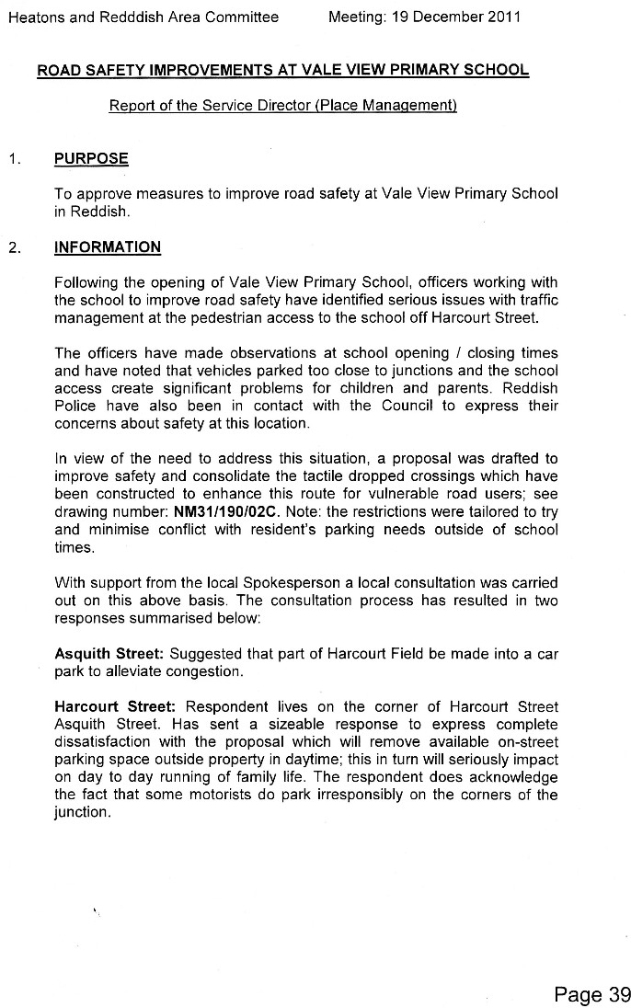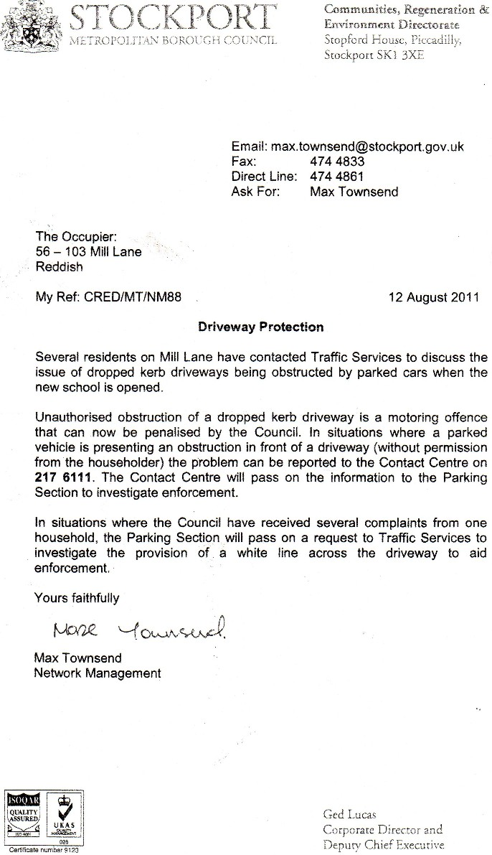
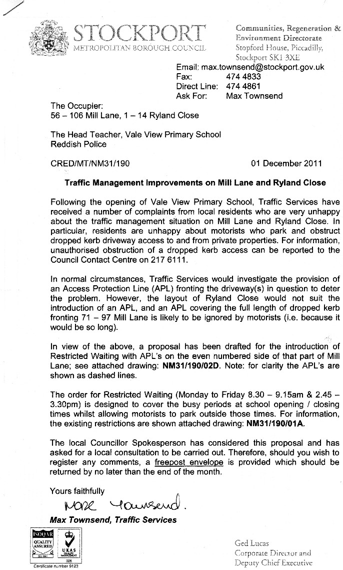
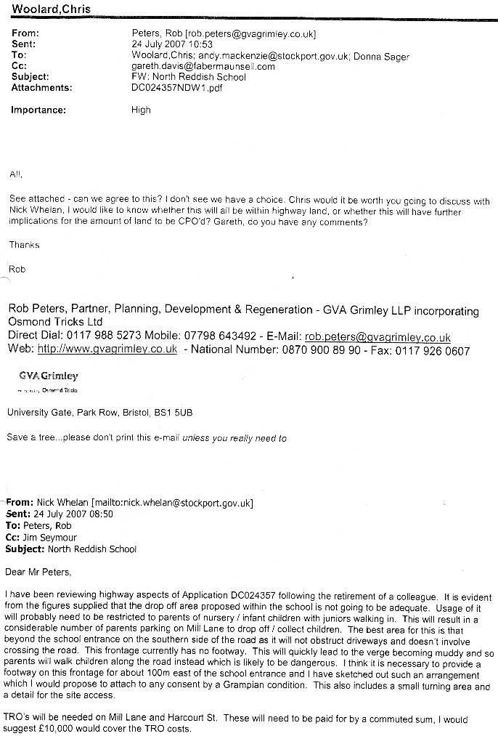

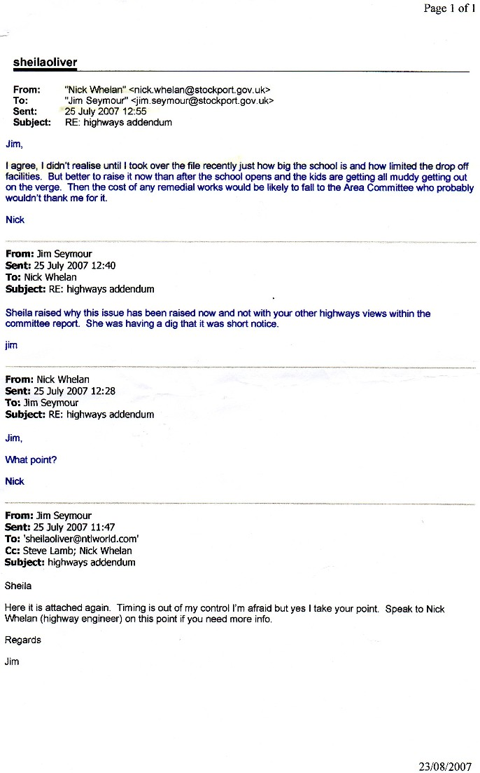
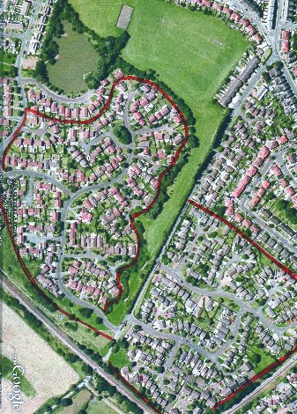
The traffic from most of the houses within the red lines has to exit via narrow Mill Lane, on which the school entrance is situated. Local people and I pointed out to the Council and planning officer Jim Seymour, and Nick Whelan in particular, the existence of all these houses forced to use that one narrow exit road. Our comments were completely ignored.
This was the state of the traffic on Mill Lane before the toxic waste dump school was built. "You are ignoring all the traffic from the hundreds of houses at the bottom of Mill Lane", I said, as did other local residents. "Don't be vexatious", they replied - Goddard, Derbyshire, Weldon, Webb, Sager, Khan, Schulz, Pantall, Smith, Candler, Bodworth and Uncle Tom Cobley and all.
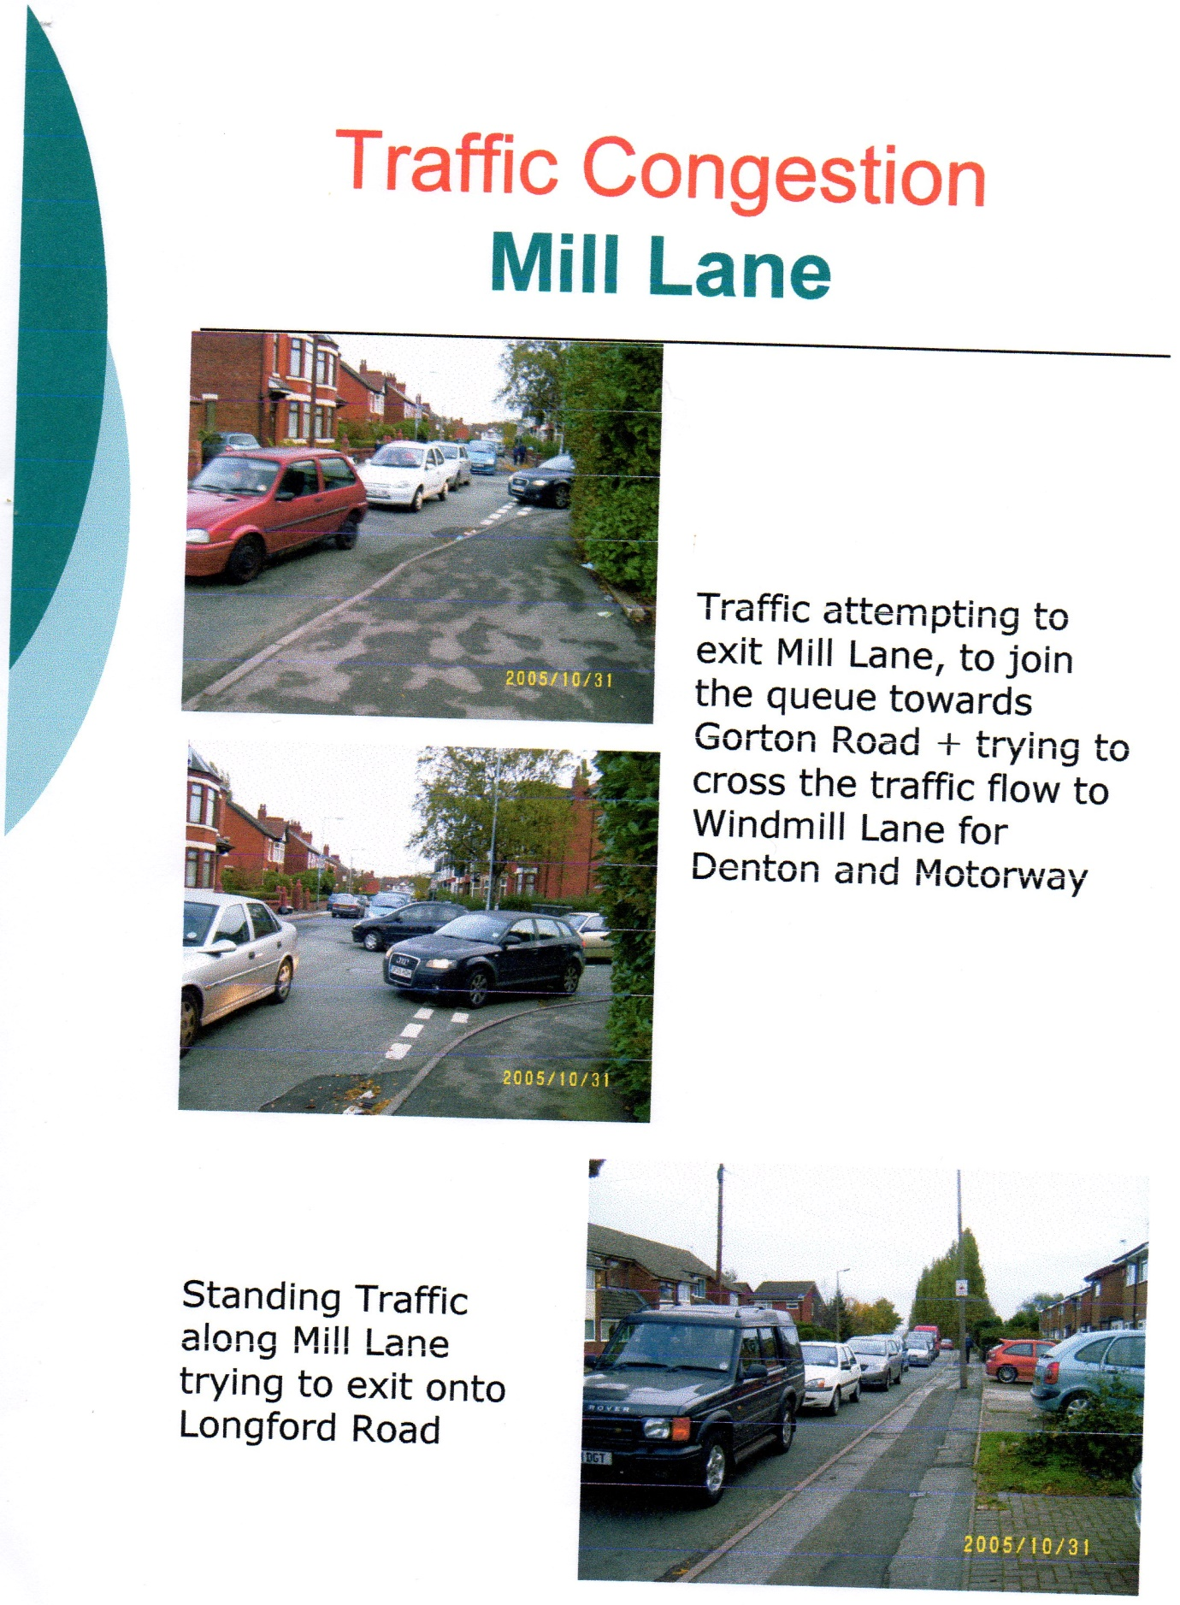

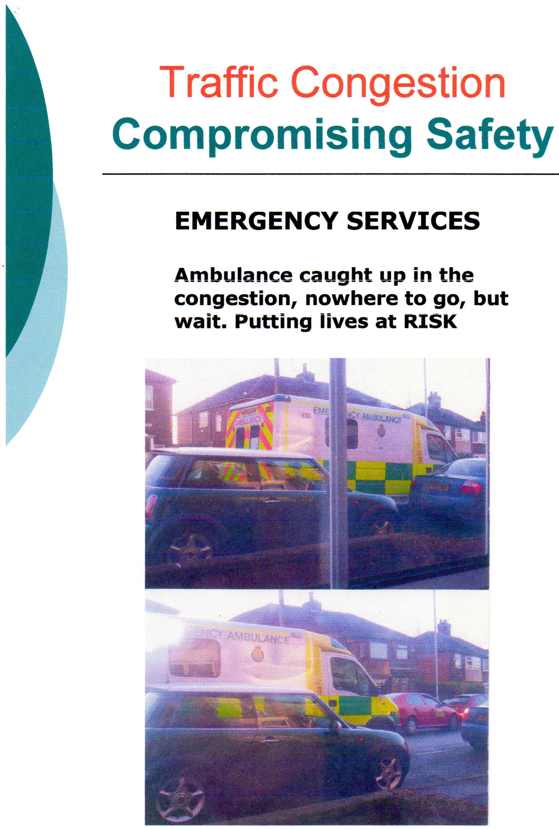
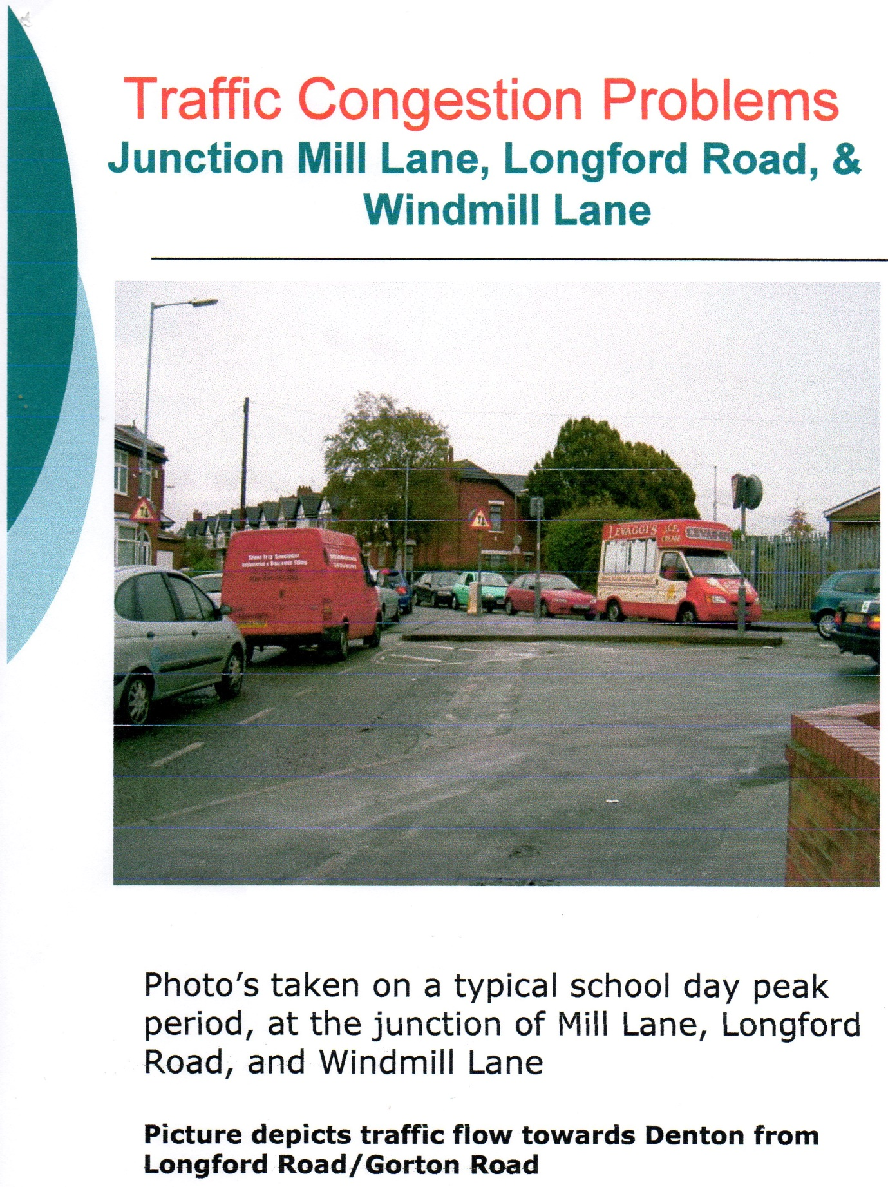

So, the corrupt LibDem Executive councillors/senior officers know I was never being vexatious and events have proved me correct, but they still ban questions on this issue – even questions not asked under the FOIA – quoting your vexatious branding.

Cllr Meikle, Cllr Derbyshire, Cllr Roberts, Cllr Hogg, Cllr Candler, Cllr Holloway, Cllr McAuley, Cllr Goddard, The Chief Executive Eamon Boylan, The Council Solicitor, Parveen Akhtar.
I look forward to your further comments and I shall distribute this letter via the Internet.

You remain my humble servant

Sheila Oliver

c.c Information Commission Board Members
Information Commission
Wycliffe House
Water Lane
Wilmslow
Cheshire
SK9 5AF

